**INNER JOIN**

1. Inner join are also called as **equijoins.**
2. They return the **matching records between the tables by equating common column.**
3. In the real time scenarios, **this is the most frequently used Join.**

**EX:**

Table 1={1,2,3,4}

Table 2={3,4,5,6}

**Note:** JOIN condition is mandatory for removing the Cartesian output.

**Ansi syntax:**

Select <column_list>

From t1 join t2

On t1.common_column=t2.common_column;

**Oracle syntax:**

Select <column_list>

From t1,t2

Where t1.common_column=t2.common_column;

**For ex,** consider the query shown below,

Select A.ename, A.sal, B.dname

From emp A, dept B

Where A.deptno = B.deptno - **JOIN condition**

And A.sal > 2000 **- FILTER condition**

Order by A.sal ;

Let us see the output shown below,

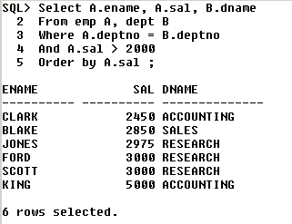

Let us consider the following 2 scenarios shown below,

**Scenario 1**

|  |  |  |  |
| --- | --- | --- | --- |
| **A** | | |  |
| **P** | **Q** | **R** |  |
|  |  |  |  |
|  |  |  |  |
| **B** | | |  |
| **P** | **S** | **T** |  |
|  |  |  |  |
|  |  |  |  |
| **C** | | |  |
| **P** | **X** | **Y** |  |
|  |  |  |  |
|  |  |  |  |
| **We want** | | | |
| **P** | **Q** | **S** | **X** |
|  |  |  |  |

**The SQL query will be,**

**Select** A.P, A.Q, B.S, C.X

From A, B, C

Where A.P = B.P **Number of joins = 2**

And A.P = C.P

**Therefore, Number of JOINS = Number of tables - 1**

**Scenario 2**

|  |  |  |  |  |
| --- | --- | --- | --- | --- |
| **A** | | |  |  |
| **P** | **Q** | **R** |  |  |
|  |  |  |  |  |
|  |  |  |  |  |
|  |  |  |  |  |
| **B** | | | |  |
| **P** | **Q** | **S** | **T** |  |
|  |  |  |  |  |
|  |  |  |  |  |
| **C** | | |  |  |
| **P** | **X** | **Y** |  |  |
|  |  |  |  |  |
|  |  |  |  |  |
| **We want** | | | | |
| **P** | **Q** | **R** | **S** | **X** |
|  |  |  |  |  |

The **SQL query is ,**

Select A.P, A.Q, A.R, B.S, C.X

From A, B, C

Where A.P = B.P

And A.Q = B.Q **Number of Joins = 3**

And A.P = C.P ;

**Therefore, Number of JOINS = Number of common columns**

If there are no common columns, then reject it saying that the two tables can be joined.

But there are some cases – where the 2 columns will be same but having different column names.

**For ex –** customerid & cid

**Display employee name, his job, his dname and his location for all the managers living in New York or Chicago**

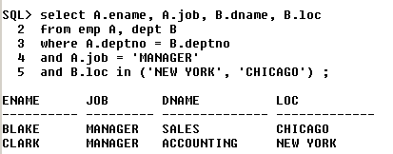

**ANSI style JOINS**:

1. This was introduced from **Oracle 9i.**
2. It is another way of writing inner joins with a few modifications.

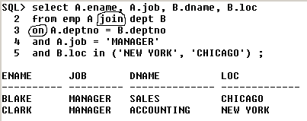

Thus we, can see the changes ,

* In the 2nd line - **,(comma)** has been **replaced by the word ‘join’**
* In the 3rd line – **‘where’** has been **replaced** with **‘on’**